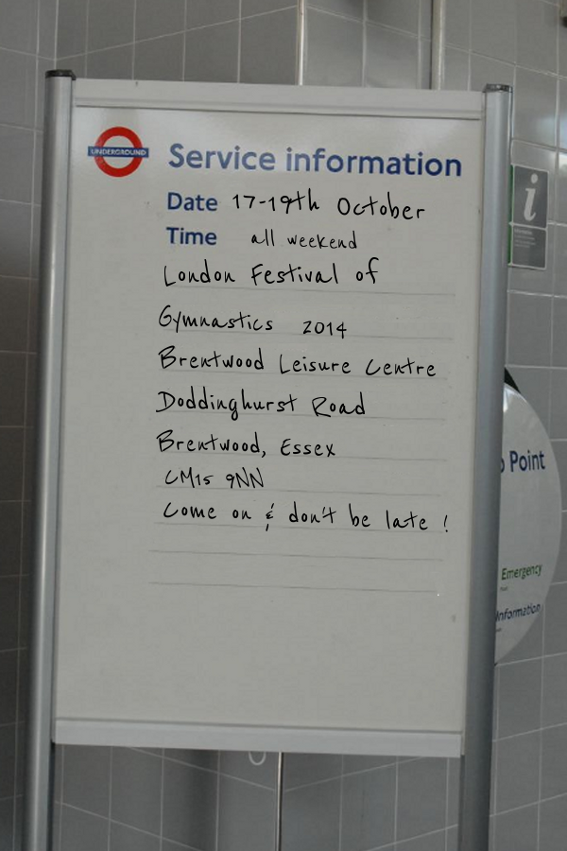

**Registration  
General Information**

|  |  |
| --- | --- |
| Name of Club |  |
| BG Club Number |  |
| Contact Name |  |
| Contact Email |  |
| Address |  |
| 🕿 No.Day | Evening |
| Number of people/gymnasts in your party: | People Gymnasts |
| Would you like to be considered to perform in the Friday Gala Evening: (This is done on a selection basis) | Yes  *No* |
| Date and time of arrival | Date: Time: |
| Preference of performance times (this is not guaranteed) | Saturday AM  PM  Sunday AM  PM |
| How many tickets you require at £5 per ticket? Note the disco will NOT be included in the cost of your festival pass |  |
| **PAYMENT** Please make cheques payable to: London Festival of Gymnastics.  Pay on line to: Bank LloydsTSB | Account Name: London Festival of Gymnastics | Sort Code: 309688 | Account Number: 00036545 | |

**Registration  
Acceptance guidance**

I/we acknowledge that the London Festival committee does not accept any responsibility for any injury, loss of property or damage incurred during the London Festival of Gymnastics.

Club Name

Signature

Date

To guarantee your place in the festival the Registration and Who’s Coming forms should be completed and returned with a £70 non refundable deposit no later than 23rd June to the Registration Department,

Due to the event being oversubscribed last year, ***registration will be on a first come first served basis***

If you would like to be mentioned in this year’s programme please send a few words and photographs to Anne McNeill by 23rd September 2014 on the following email address: [Anne.mc3m@btinternet.com](mailto:Anne.mc3m@btinternet.com), or send to her home address: 3A Macroom Road, Maidavale, London, W9 3HY**.**

Final Payment will be due no later than ***23rd September 2014****.* Failure to send this payment on time could result in forfeiting your place. *Please send to:*

***London Festival of Gymnastics Registration Department*** *8 Crayford Way  
Crayford  
KENT  
DA1 4LQ  
Tel No: 07801 355370  
Email:* [tgriffiths74@gmail.com](mailto:tgriffiths74@gmail.com)

**Who’s coming?**

**CLUB NAME:**

These passes only apply if you are a gymnast, coach or chaperone. If you have any spectators with your party they need to purchase spectators tickets.

There is an Administration Fee of £35 per club. There is a minimum charge for a team of 10 people or less.

As a gesture of goodwill there will be 2 free coach passes for every team registered.

|  |  |  |  |
| --- | --- | --- | --- |
| **CLUBS WITH 11 GYMNASTS OR MORE** | **COST** | **No.** | **TOTAL** |
| Administration fee per club | £35 | ---- | £35 |
| Entry fee per gymnast and additional coaches for 1day performance  (6 min performance, entrance fees, a medal, a t-shirt, and if you’re performing on Saturday a free entry to Friday night’s gala evening) | £17.50 |  |  |
| Entry fee per gymnast and additional coaches for 2 day performance (Sat and Sun only)  (6 min performance each day, entrance fees, a medal, a t-shirt, and free entry to Friday nights gala evening ) | £27.50 |  |  |
| Entry fee per chaperone for 1 day | £10.00 |  |  |
| Entry fee per chaperone for 2 days | £20.00 |  |  |
| Party tickets | £5 |  |  |
| **CLUBS WITH 10 GYMNASTS OR LESS** | **COST** | **No.** | **TOTAL** |
| Administration fee per club | £35 | ------ | £35 |
| Entry fee per team (with 10 gymnasts or less) for 1 day performance  (6 min performance, entrance fees, a medal, a t-shirt, and if your performing on Saturday a free entry to Friday nights gala evening. | £175 |  | £175 |
| Entry fee per team (with 10 gymnasts or less) for 2 day performance (Sat and Sun only)  (6 min performance each day, entrance fees, a medal, a t-shirt, and free entry to Friday nights gala evening) | £275 |  | £275 |
| Party tickets | £5 |  |  |
| Entry fee per chaperone for 1 day | £10.00 |  |  |
| Entry fee per chaperone for 2 days | £20.00 |  |  |
| TOTAL COST |  |  |  |

**Passes & Tickets**

**CLUB NAME:**

Please send this form with your final Payment no later than the 23rd September 2014.

|  |  |  |
| --- | --- | --- |
| **PAYMENT** | **NUMBER** | **AMOUNT** |
| Club Registration Fee | £35 x 1 | £35 |
| Total 2 Day Passes (Sat and Sun only) | £27.50 x |  |
| Total 1 Day Passes (Saturday) | £17.50 x |  |
| Total 1 Day Passes (Sunday) | £17.50 x |  |
| Team of 10 Gymnasts or less 2 Day Passes (Sat and Sun only) | £275 Number of passes |  |
| Team of 10 Gymnasts or less 1 Day Passes (Saturday) | £175 Number of passes |  |
| Team of 10 Gymnasts or less 1 Day Passes (Sunday) | £175 Number of passes |  |
| Total Chaperone 2 Day Passes (Sat and Sun only) | £20 x |  |
| Total Chaperone 1 Day Passes (Saturday) | £10 x |  |
| Total Chaperone 1 Day Passes (Sunday) | £10 x |  |
| Party Tickets | £5 x |  |
| TOTAL |  |  |

**Please send to:**

**London Festival of Gymnastics Registration Department**  
8 Crayford Way  
Crayford  
KENT DA1 4LQ  
Tel No: 07801 355370  
*Email:* [tgriffiths74@gmail.com](mailto:tgriffiths74@gmail.com)

**Insurance & Image Capture**

**British Gymnastics Membership for Gymnasts**

All gymnasts participating at the Festival must be members of British Gymnastics (at a minimum of Bronze Level) to comply with the insurance cover. Membership of British Gymnastics includes the required insurance cover.

The Membership starts on the 1 October so please make sure that registration is made in September 2014.

Please note that schools wishing to register to take part in the Festival are covered for insurance if they are members of British Schools Gymnastics Association and therefore they must quote all membership details with their registration application

(*Please ensure all gymnasts carry their BG membership cards on them as they maybe asked to show them at some point during the event)*

Full details of BG membership will be required and an Excel spreadsheet will be sent out for completion once your team has been accepted.

**Image Capture**

We do not have anyone recording performances this year, therefore if you would like to video your performance you can bring your own camera, but these will only be allowed in the main arena (not on the balcony) and NOT in any other areas within the centre.

**Membership & Qualifications**

* The Lead coach with the team at the London Festival must have a minimum of Level 2 in the discipline(s) being performed.
* Additional coaches of a minimum level one may also attend.
* At least one of the coaches in attendance must have a qualification in the relevant discipline(s) to cover the difficulty of ALL skills being performed by the gymnasts in the Club’s Festival routine.
* Please ensure that all coaches have an up to date Enhanced BG CRB and a current SPC (Safeguarding and Protecting Children) qualification registered with BG.
* Chaperones must have a minimum of Bronze Level British Gymnastics membership and an Enhanced BG DBS.

Full details of BG membership will be required and an Excel spreadsheet will be sent out for completion once your team has been accepted.

Any queries about Membership and Qualifications can be directed to:

**London Festival of Gymnastics Registration Department**  
8 Crayford Way, Crayford  
KENT DA1 4LQ  
Tel No: 07801 355370  
*Email:tgiffiths74@gmail.com*

**T-Shirt Ordering**

**CLUB NAME**

A T-Shirt is included in your festival pass, this applies for all gymnasts who are performing and coaches.

Chaperones can purchase T shirts at £6.50 each.

All T shirts can be collected when you register your team at the event.

Please indicate T-Shirt sizes:

|  |  |  |  |  |  |  |  |
| --- | --- | --- | --- | --- | --- | --- | --- |
| T Shirts (Included in the price) | | | | | | T Shirts (Not Included in the price) | |
| Adults | | | Children | | | Chaperone | |
| XXL | 50/52” |  | 12/13 | 34/36” Youth XL |  | Number of T shirts | Size |
| XL | 46/48” |  | 9/11 | 32/34” Youth Large |  |  |  |
| Large | 42/44” |  | 7/8 | 30” Youth Medium |  |
| Medium | 38/40” |  | 5/6 | 26/28” Youth Small |  |
| Small | 34/36” |  | 3/4 | 22/24” Youth X Small |  |
|  | | | | | |  | |

Please note that once the T-shirts have been ordered there can be no alterations to sizes or numbers.

If I do not receive your order by the date below I am afraid you will not be given any t-shirts.

Please complete the form above and send it to the registration department by the ***12th September 2014***

Please send to:

**London Festival of Gymnastics Registration Department**  
8 Crayford Way, Crayford  
KENT DA1 4LQ  
Tel No: 07801 355370  
*Email:* [tgriffiths74@gmail.com](mailto:tgriffiths74@gmail.com)

**Equipment**

**CLUB NAME**

Will you be bringing your own Equipment to the London Festival of Gymnastics? (please tick the boxes below)

|  |  |  |
| --- | --- | --- |
| On Friday 17th October | Yes | No |
| On Saturday 18th October | Yes | No |
| On Sunday 19th October | Yes | No |
| Do you require help to unload equipment | Yes | No |

The equipment available for use is listed below. Please tick the appropriate boxes if you would like to use it.

If you do not tick the boxes below then the equipment will not be available for you to use.

|  |  |  |
| --- | --- | --- |
| 6 x Safety Landing Mats | Yes | No. |
| 2 x Throw Mats | Yes | No |

Please note that all equipment must be in the loading bay between 8.00am and 9.30am on either day – NO LATER.

**Due to Brentwood fire safety regulations, any equipment arriving after this time will not be allowed into the loading bay.**

If you would like to drop your equipment Friday night, the loading bay will be open from 6.30pm. You will not be able to collect your equipment until the end of the day’s performances.

All equipment must meet Health and Safety requirements as it will be checked per BG manual.

Please complete the form above and send it to the registration department by the ***23rd September 2014***

If you have any questions regarding equipment please contact us before the event or speak to us on your arrival.

Please send to:   
**London Festival of Gymnastics Registration Department**  
8 Crayford Way, Crayford  
KENT DA1 4LQ  
Tel No: 07801 355370  
*Email:* tgriffiths74@gmail.com

**Music**

**CLUB NAME**

|  |  |
| --- | --- |
| Contact Name |  |
| Contact Telephone No. |  |
| Email Address |  |
| Title of Music |  |
| Length of the Music |  |

Please make sure that your music is copied onto a CD, no tapes or mini discs. Make sure that it is a good clear copy and is ready to play and if there is more than 1 track please make sure this is clearly labelled. Please make sure you bring at least 2 copies of music, one for warm up and one for a backup.

Please make sure that your music is labelled clearly on both the CD and the case and NO post it notes!

Due to the popularity of the festival, we are on a tight time schedule and therefore your music must not be longer than 6 minutes inclusive of marching on and off and moving of equipment, if it is any longer than 6 minutes then we may have to cut it on the day.

Please adhere to the copyright law as stated by British Gymnastics. For more information please see the website WWW.PPLUK.COM

Please note that the London Festival Committee and British Gymnastics will not accept any responsibility if legal action is taken against a club if they choose to use Disney, Lloyd Webber or Cirque du Soleil music.

Please send your music with this form by the ***23rd September*** to:

**London Festival of Gymnastics Registration Department**  
8 Crayford Way, Crayford  
KENT DA1 4LQ  
Tel No: 07801 355370  
*Email: tgriffiths74@gmail.com*

**Ticket Bookings**

|  |
| --- |
| **Bookings can only be made on line:** **www.ticketweb.co.uk**  **For more information go to www.londongym.org.uk**  **Tickets will go on sale in July 2014** |

|  |  |  |  |  |  |
| --- | --- | --- | --- | --- | --- |
|  |  | **Booked in Advance** |  | **On the day** |  |
|  |  |  |  |  |  |
| **Friday 17 October Gala Performance**  The performance starts at 7.30pm followed by a firework display. |  | **£7.50** |  | **£10.00** |  |
| **Saturday 18 & Sunday 19 October**  Morning performances start at 10am |  | **£5.00** |  | **£7.50** |  |
| **Saturday 18 & Sunday 19 October**  Afternoon performances start at 2.30pm |  | **£5.00** |  | **£7.50** |  |

Children under 2yrs are permitted free provided they share a seat with an Adult.

There is disabled seating and wheelchair access available.

TICKETS CANNOT BE EXCHANGED OR REFUNDED

On arrival staff on reception will exchange tickets for wristbands. We advise you to arrive early as seats are no longer numbered. If your child is performing and you want them to sit with you after their performance they will need a spectator ticket as their gymnast pass will not give them access to the spectator seating.

**On Saturday 18th October London presents:**

**THE LONDON DISCO – themed fancy dress**

**From 8.00-11.30pm at the Brentwood Leisure Centre**

**Soft drinks available in Marquee.**

**Alcoholic Beverages available in the bar (ID required)**

**Tickets are £5 each -**

**Please order these on the registration form**

[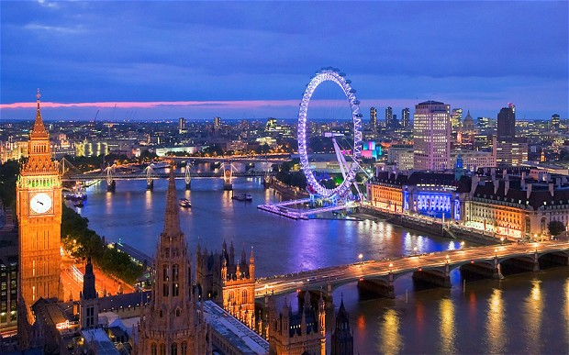](http://www.ssauk.com/wp-content/uploads/2013/07/london_2423609b.jpg)

**Gala Evening**

**Date:** Friday 19th October

MCj03260520000[1]

**Time:** 7.30-10.00pm (Centre will open at 6.30pm)

**MCj03260520000[1]Venue:** Brentwood Centre

Doddington Road

Pilgrims Hatch

Brentwood

Essex, CM15 9NN

We will be selecting a number of teams to perform a 4 minute routine at the Gala Evening.

After the performances have finished the bar will be open for refreshments.

If spectators wish to come to the Gala evening, tickets are £7.50 per person (pre booked) £10.00 per person (on the door).

There will also be a fireworks display to open the weekends Festival, which will begin at 9.45pm and the evening will finish at 10pm.

**Map**

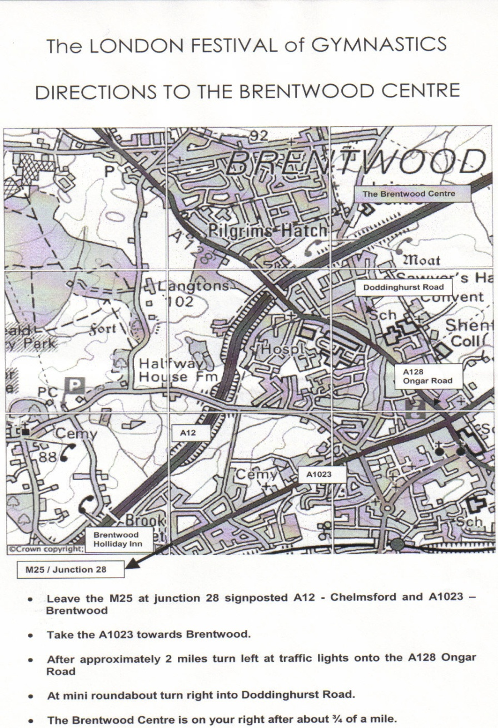

**Key Deadline Reminders**

**20th June – Pre Registration**  
  
**12th September – T-shirt orders  
  
23rd September – Programme words needed  
  
23rd September – Final payment  
  
23rd September – Tell us who is coming?  
  
23rd September – Send us your music**

**23rd September – What equipment are you bringing?**